Intellij - create a new Web application that uses Apache Tomcat

Java Enterprise development is not supported in the free IntelliJ IDEA Community Edition.

Web Application support is an Ultimate feature, available in **IntelliJ IDEA Ultimate** only.

**IntelliJ IDEA Ultimate** :

Download trial version. When you start the IDE, it will ask you to choose trial version. You need to simply sign up with Jetbrains. Takes about 5 minutes.

1. Click New Project on the Welcome screen or select File | New | Project.
2. From the Generators list, select Jakarta EE.
3. Name the new project, select a build tool, a language you want to use, and select the Web application project template.
4. Don't select or add an application server, we will do it later.

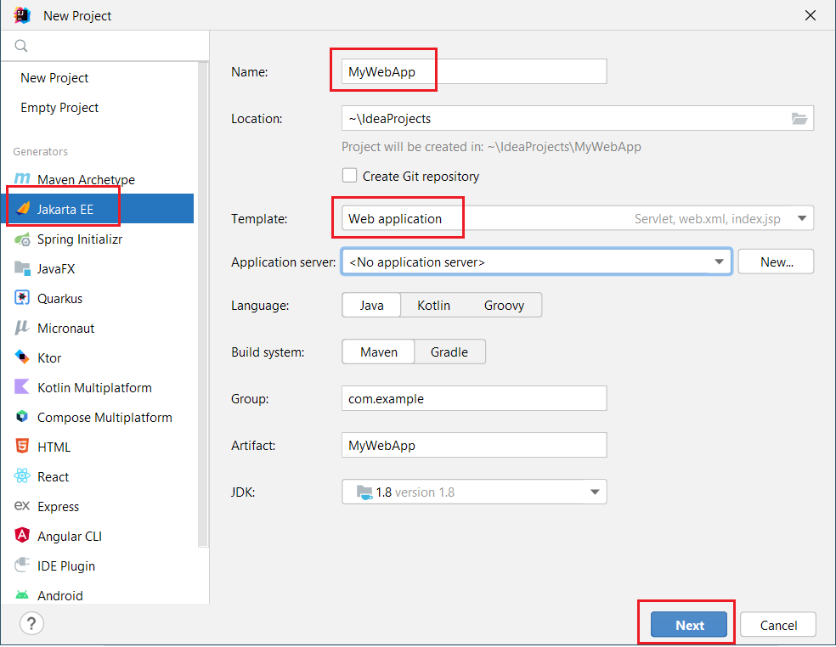

1. Click on next
2. In the Dependencies list, you can see that the web application template includes only the Servlet framework under Specifications by default. Don’t change anything. Click Create.

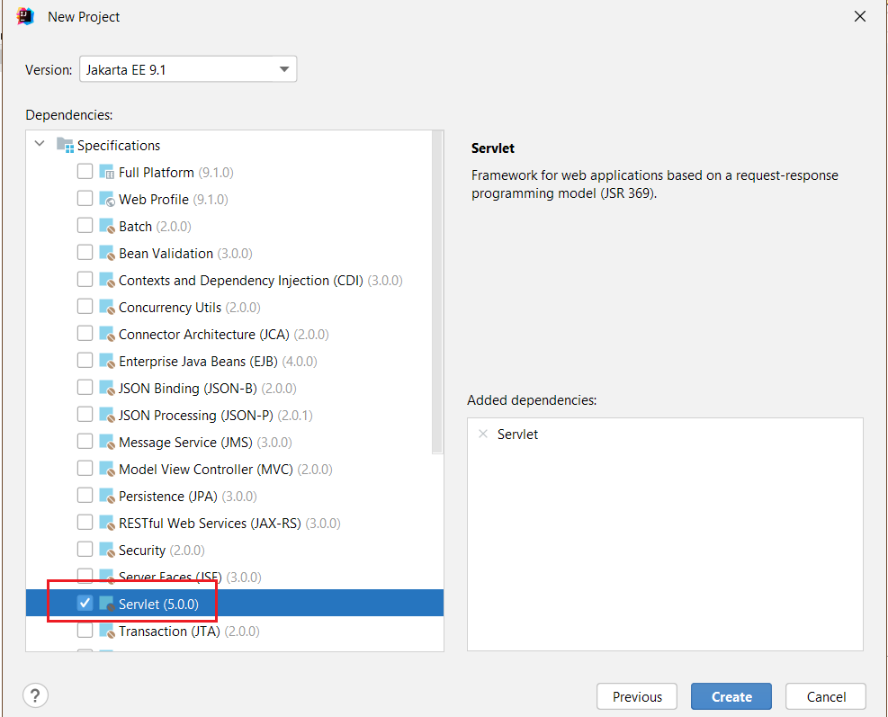

1. A complete Maven project is created for you with a sample servlet, a index.jsp and pom.xml with servlet-api and junit 5 dependencies!

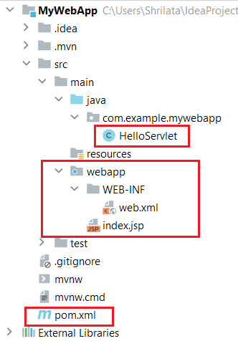

Two ways to add tomcat:

1. Download Tomcat 10. Unzip and store in Local folder system.
2. Use IntelliJ “Smart Tomcat” Runtime plugin

Use IntelliJ “Smart Tomcat” Runtime plugin:

But you still need to download tomcat!! So here are the softwares that worked for me:

* Tomcat 10.1.6
* Intellij Ultimate 2022.3.2
* JDK 17
* Lets first install the plugin. File | Settings | plugins

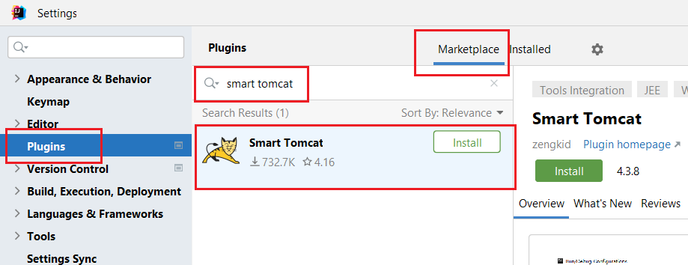

* Click on install to install this plugin.
* Lets now setup this tomcat in Intellij
* Run | Edit Configuration

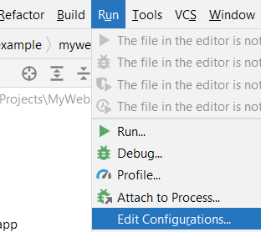

* You will see a totally blank screen. Click on + top left corner.

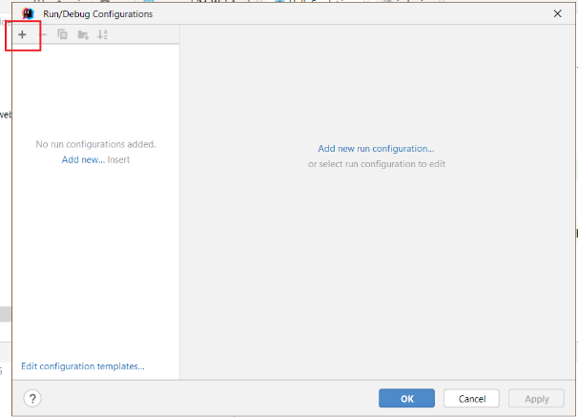

* Select Smart Tomcat:

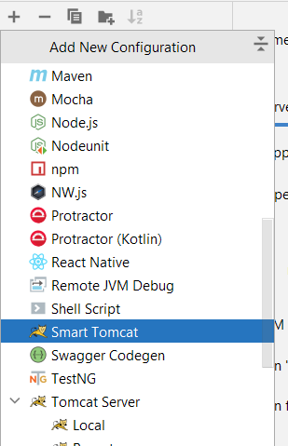

I gave name as Tomcat10 and click on Configure to configure my downloaded tomcat

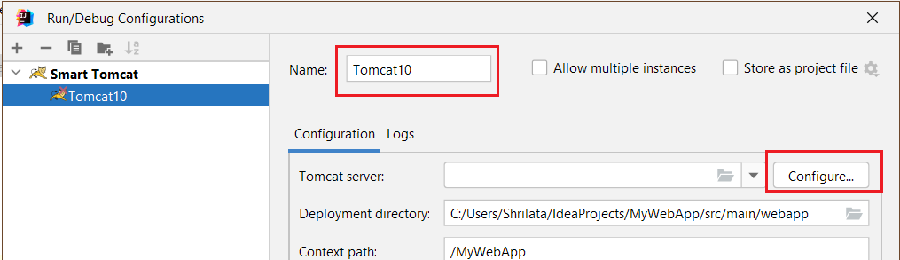

* Select + :

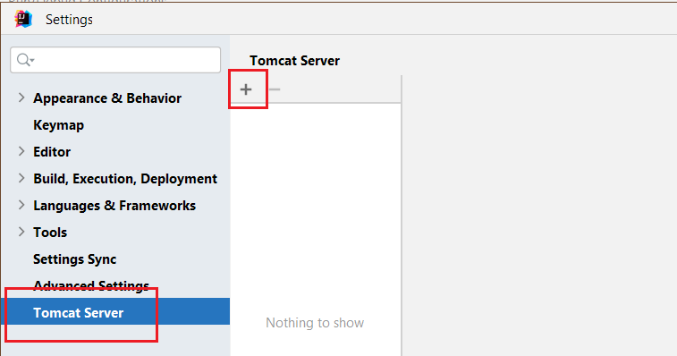

* Select Tomcat location, Apply, close
* Now you will see the following dialog, Keep all default options as is:

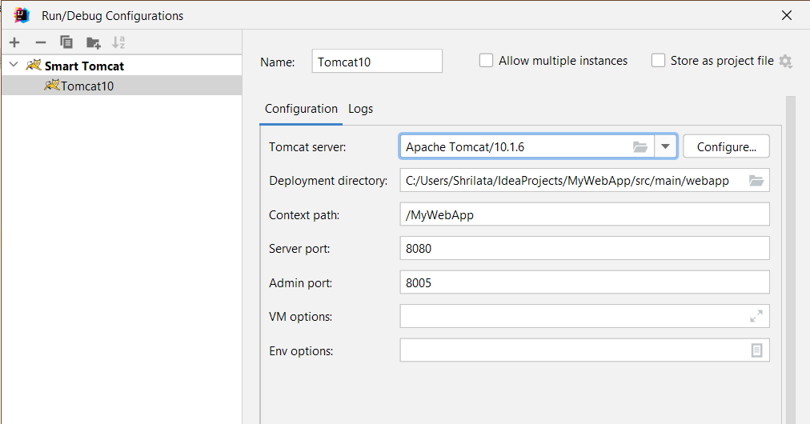

* Lets run Tomcat. Shift+f10

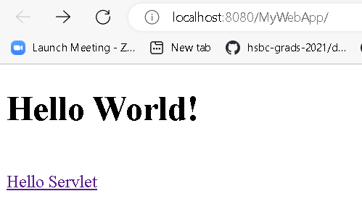

Local Tomcat not working at all!!